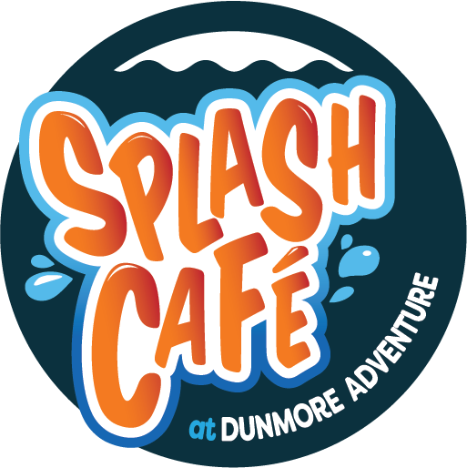

STARFISH SUMMER CAMP LUNCH DEAL
PRINTABLE PRE-ORDER FORM 2025
Starfish collection time: 1pm Sharp!!

STARFISH NAME: ______________________________

1 SMALL CHEESE ROLL LUNCH €5.00
2 SMALL HAM ROLL LUNCH €5.00
3 SMALL HAM & CHEESE ROLL LUNCH €5.50
4 Mini 6” PIZZA LUNCH €5.50
5 GOUJONS (2) AND CHIPS €5.50

Each lunch ALSO includes a bag of crisps, and a bottle of water, or juice,
delivered to your camper at lunch time.

Please insert your meal choice NUMBER below

 | Monday | Tuesday | Wednesday | Thursday | Friday
LUNCH CHOICE:
NUMBER
Total: | € | € | € | € | €

PLEASE RETURN TO SPLASH CAFÉ STAFF MEMBER WITH YOUR PAYMENT

Amount due: €____________

